1. Import project in Eclipse and Import build path in lib folder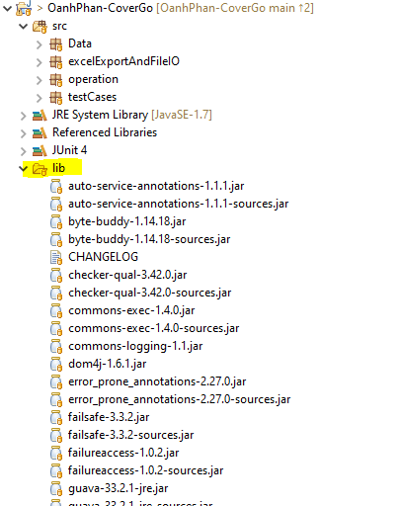
2. If in Libraries tab have fail path => Remove those paths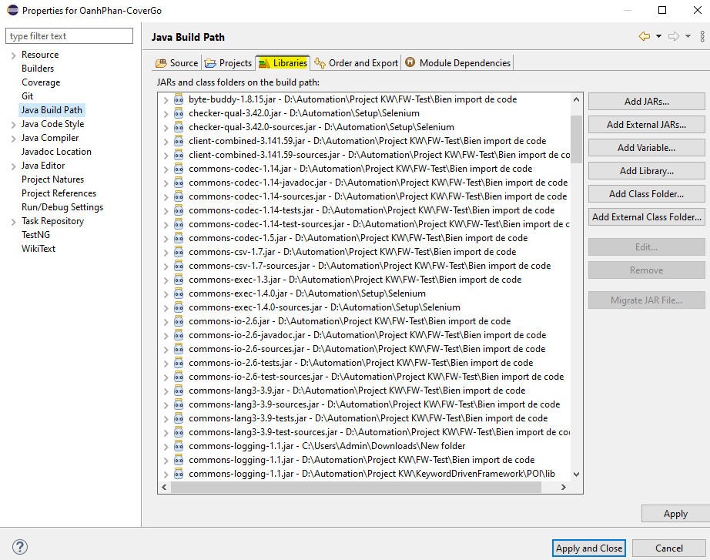
3. Object in object.properties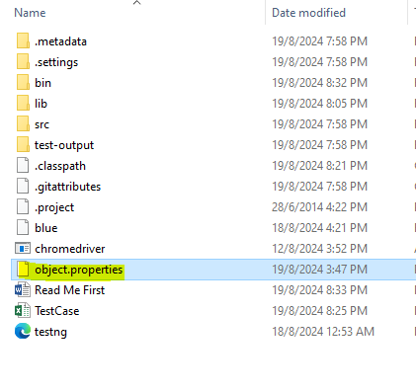
4. All test cases in TestCase excel file
5. Run ExectueTest

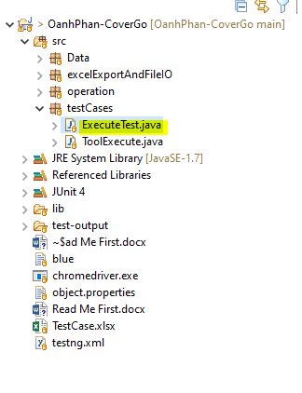

1. Open Testcase excel file to read the results ***(When running automation don’t open the Testcase file)***